Alternatively, we will send one to you to return to us when we receive your initial written complaint.

Where the patient is incapable of providing consent due to illness, accident or mental capacity, it may still be possible to deal with the complaint. Please provide the precise details of the circumstances that prevent this in your covering letter.

Please note that we are unable to discuss any issue relating to someone else without their express permission, which must be in writing, unless the circumstances above apply. You may also find that if you are complaining on behalf of a child who is capable of making their own complaint, we will expect that child to contact us themselves to lodge their complaint.

We may still need to correspond directly with the patient, or may be able to deal directly with the third party. This depends on the wording of the authority provided.

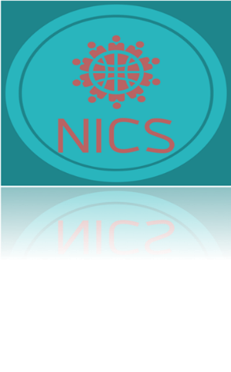

If you are dissatisfied with the outcome

You have the right to approach the Parliamentary & Health Service Ombudsman.
Their contact details are:

The Parliamentary and Health Service Ombudsman
Millbank Tower
30 Millbank
London
SW1P 4QP

Tel: 0345 0154033

Website: www.ombudsman.org.uk

http://www.ombudsman.org.uk/make- a-complaint (to complain online or download a paper form).

You may also approach Healthwatch or the Independent Health Complaints Advocacy for help or advice;

The local Healthwatch can be found at:
http://www.healthwatch.co.uk/

The IHCA is able to be contacted at: http://www.seap.org.uk/services/ nhs-complaints-advocacy/

Complaints Procedure

North West Surrey Integrated Care Services (NICS) Ltd

Making a Complaint

Most problems can be sorted out quickly and easily with the person concerned, often at the time they arise, and this may be the approach you try first.

Where you are not able to resolve your complaint in this way and wish to make a formal complaint you should do so, preferably in writing as soon as possible after the event and ideally within a few days, giving as much detail as you can, as this helps us to establish what happened more easily. In any event, this should be:

- Within 12 months of the incident, or

- Within 12 months of you becoming aware of the matter

If you are a registered patient you can complain about your own care. You are not normally able to complain about someone else’s treatment without their written authority. See the separate section in this leaflet for what to do in this case.

We are able to provide you with a separate
complaints form to register your complaint and this includes a third-party authority form to enable a complaint to be made by someone else. Please ask at reception for this. You can provide this in your own format providing it covers all of the necessary aspects.

Send your written complaint to:

NICS HR Lead: Mr N. Glynn

nics.admin@nhs.net

You may also make your complaint directly to NHS England, who commission our service:

By telephone: 03003 11 22 33

By email: england.contactus@nhs.net

What We Do Next

We aim to settle complaints as soon as possible.

We will usually acknowledge receipt within three working days, and aim to resolve the matter as soon as possible but will give you some idea of how long that may take at the outset. You will then receive a formal reply in writing, or you may be invited to meet with the person(s) concerned to attempt to resolve the issue. If the matter is likely to take longer than this we will let you know, and keep you informed as the investigation progresses.

When investigating a complaint, we will attempt to see what happened and why, to see if there is something we can learn from this, and make it possible for you to discuss the issue with those involved if you wish to do so.

When the investigations are complete, a final written response will be sent to you.
Where your complaint involves more than one organisation (e.g. social services) we will liaise with that organisation so that you receive one coordinated reply. We may need your consent to do this. Where your complaint has been initially sent to an incorrect organisation, we may seek your consent to forward this to the correct person to deal with.

The final response letter will include details of the result of your complaint and also your right to refer the matter further to the Parliamentary and Health Service Ombudsman (details shown elsewhere in this leaflet) if you remain dissatisfied with the response.

Complaining on Behalf of Someone Else

We keep to the strict rules of medical and personal confidentiality. If you wish to make a complaint and are not the patient involved, we will require the written consent of the patient to confirm that they are unhappy with their treatment and that we can deal with someone else about it. In the event the patient is deceased, then we may agree to respond to a family member or anyone acting on their behalf or who has had an interest in the welfare of the patient.

Please ask at reception for the Complaints Form, which contains a suitable authority for the patient to sign to enable the complaint to proceed.

